You will only be able to access and print off your certificate when you have fully completed the Cybercrime and online safety eLearning module (all sections showing complete) and have marked complete the evaluation sections (via the Learning Pool page).
When you access the eLearning course via the ‘Derbyshire Learning On-line’ site, you are able to monitor your progress through the course by the progress bars at the bottom of each section on the home screen. To complete the module, the progress bar for each section has to be whole.
In the example below you can see that one section is complete, but the second section is only partially complete. You must complete all sections of the course for your training record to show completed.
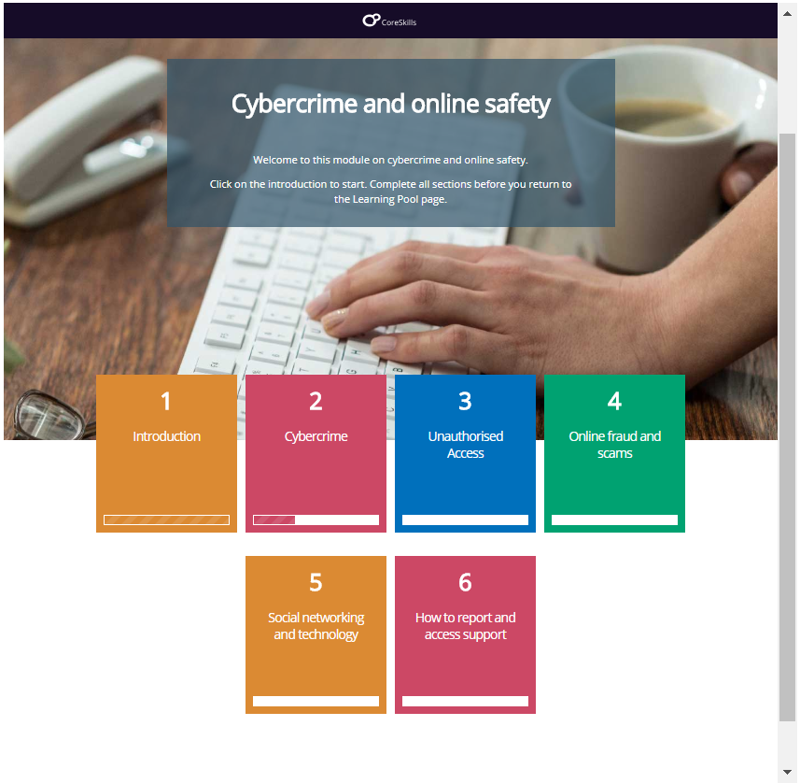

This progress bar is showing a striped area meaning that this section is completed.
Progress bar is showing a partial completion.

Scroll down using the sliding bars to reveal content throughout the module.
Progress bar is showing section not started

To begin the module, click into the first box – ‘Introduction’. Make sure you do not miss any content on each page. Scroll down using the sliding scroll bars on the right-hand side, until you cannot scroll any further, completing all the activities as you go.
Only once you are at the bottom of the page, and have completed all the activities, should you click the ‘Next’ button. The next page will explain what to do if you have missed something, but are not sure what you’ve missed.
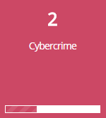
Left click on the section where it is showing you have missed bits. In this example, ‘Cybercrime’.

If you have not started a section then no progress bar or part progress bar will be displayed. To identify the bits missed in this section left click on the Progress bar.
In each section of the course the Progress Bar will be displayed along the top of the screen. Left click on the Progress Bar.
The bits missed are displayed down the right hand side of the screen. They can be identified by a white rectangle (completed sections show in stripes). Left click on a white link to take you straight to a section which has been missed. 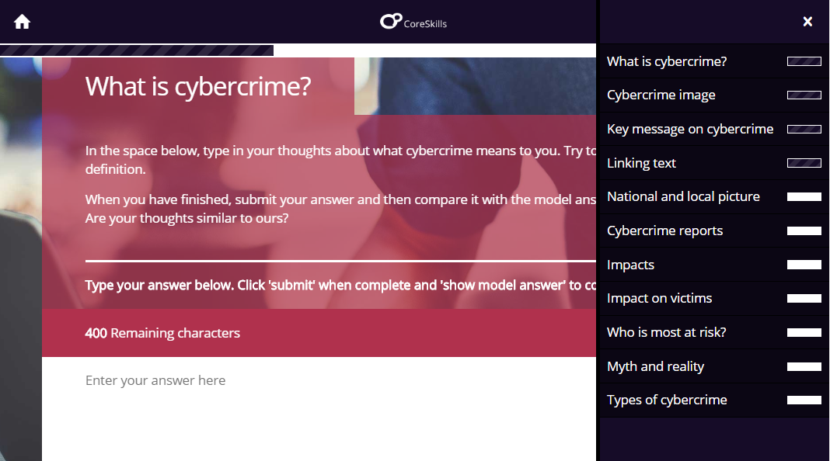
Click on each white box to take you straight to the bits you have missed.

Revisit each section missed and complete all the activities in that section. You may need to click on images / headings /arrows/pins/drop down sections or answer questions depending on the activity you missed. You may just need to read the information.
As you complete each section, the progress bar will extend across the screen, until it shows the section is complete – shown below.
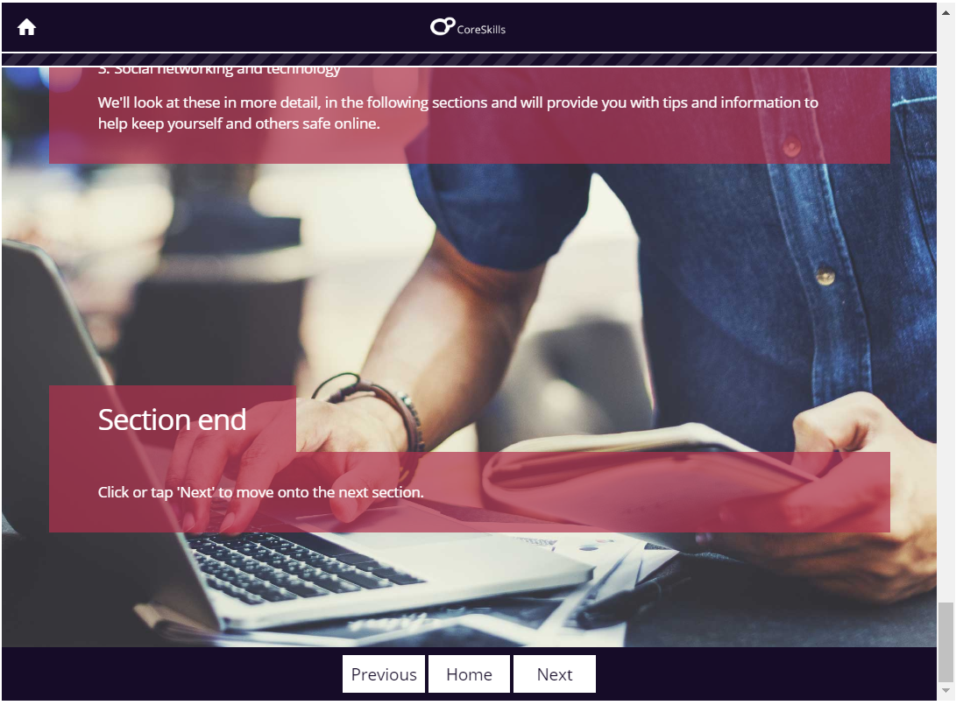
On each page, make sure you scroll down and complete all the activities on that page, before you click onto the ‘Next’ button, which will take you to the next page.
When you have completed all the activities missed on a page, click ‘Home’ to return to the main menu and repeat for any other sections that are not fully complete.
After you have completed all sections, return to the main menu, then exit the course by clicking on the button or the X, located at the top right of your screen.

You will then return to the main Learning Pool page where you MUST complete the ‘evaluation’ and print off your certificate.
This is explained in more detail overleaf…

When you have returned to the Learning Pool page you may wish to access and print off some of the Resources available on the page. This is optional.
You should then scroll down to the ‘Evaluation’ section as shown below…
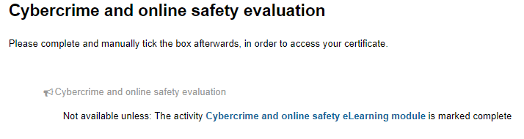
Click on the web-link to access and complete the course evaluation. Tick the box to mark as complete.
As you will see above, you can only access the evaluation if you have successfully completed the eLearning module.
The certificate section follows the evaluation.
You will only be able to access and print off your certificate when you have fully completed the e-learning module (all sections showing complete) and have submitted your evaluation.
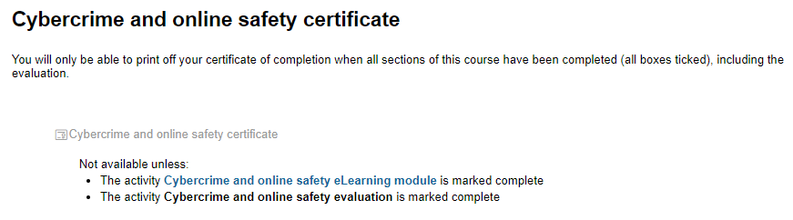
Click on the web-link to access your certificate. You should print a copy for your records.
If you still have problems accessing your certificate, please email dlo@derbyshire.gov.uk.

