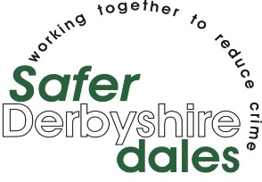

Record sheet of incidents of Anti-Social Behaviour in accordance with The Anti-Social Behaviour, Crime and Policing Act 2014

Information communicated to the District Council may be disclosed with other relevant organisations (for ex. The Police) to help address the issues you report.
Do you give permission for the information to be shared. Yes/No (Please delete as appropriate)

Name & Address of person making the complaints: |  | Name of offender/s |  | Address of offender/s:

Date | Day | Time Started | Time Finished | What is happening, who is involved include how you are affected | Signature/name of Aggrieved person and/ or witness
Please return the form to:
Online:
Communitysafety@derbyshiredales.gov.uk

By Post to:
Community safety
Derbyshire Dales District Council
Town Hall
Bank Road
Matlock
Derbyshire
DE4 3NN

If you would like to discuss:
Tel: 01629 734487

This information is available free of charge in electronic, audio, Braille and large print versions, and in other languages on request. For assistance in understanding or reading this document, please call 01629 761187.

